ЕГЕМБЕРДИЕВА Айнур Килишбеккызы,
Зоя Космодемьянская атындағы №23 мектеп-лицейінің ағылшын тілі пәні мұғалімі.
Шымкент қаласы
ART

Learning objectives (s) that this lesson is contributing to |  | 9.4.2.1 understand specific information and detail in texts on a growing range of familiar general and curricular topics, including some extended texts;  9.5.3.1 write with moderate grammatical accuracy on a growing range of familiar general and curricular topics;
Lesson objectives  (Assessment criteria) |  | Learners will be able to:  - Recognize specific information from given text  - Answer the questions  - Write 6-7 sentences with moderate grammatically accuracy using the given criteria
Level of thinking skills |  | LOTS and HOTS
Plan
Time | Teacher’s actions |  | Students actions | Assessment | Resources
5 min  5 min | The lesson greeting.  The teacher sets the lesson objectives, letting students know what to anticipate from the lesson  Teacher introduces with the assessment criteria  1.Warm up. (I)  Lost words  T gives cards with mixed words to define the theme.  Ss order the words in order to make the proverb and quote.  1.Art is not what you see, but what you make others see.  2.Art is not a thing, it is a way.  3.Art is long , life is short |  | Ss greeting  S orders the words and makes up correct sentences | Mutual assessment | Cards
6 min  4 min  5 min  12-15 min  5 min | Task 1  Pre-reading task  Teacher asks CCQ for revising previous knowledge about the ART  Think-Pair-Share strategy (I,P,Gr)  Teacher shows the picture. Students look at the picture and try to describe and guess “What the text is about?”  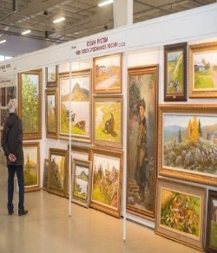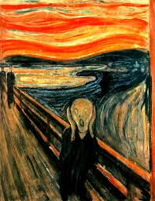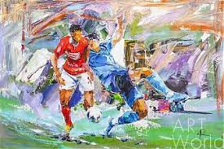  Scaffolding for this task by using CCQ  D: Individual work for isolated student  Task 2. (I)  Reading for detail  The history of graffiti  The first drawings on walls appeared in caves thousands of years ago. Later the Ancient Romans and Greeks wrote their names and protest poems on buildings. Modern graffiti seems to have appeared in Philadelphia in the early 1960s, and by the late sixties it had reached New York. The new art form really took off in the 1970s, when people began writing their names, or ‘tags’, on buildings all over the city. In the mid seventies it was sometimes hard to see out of a subway car window, because the trains were completely covered in spray paintings known as ‘masterpieces’.  For decades graffiti has been a springboard to international fame for a few. Jean-Michel Basquiat began spraying on the street in the 1970s before becoming a respected artist in the ’80s. The Frenchman Blek le Rat and the British artist Banksy have achieved international fame by producing complex works with stencils, often making political or humorous points. Works by Banksy have been sold for over £100,000. Graffiti is now sometimes big business.  Differentiation by resource: Teacher gives unknown words with translation for less able students  5 W activity (P)  Teacher shows questions on the board Ss will answer  1.Why was the seventies an important decade in the history of graffiti?  2. What is a 'masterpiece' in graffiti?  3. What was the main motivation for the first taggers?  4.When Basquiat began spraying on the street?  4. Who coined the phrase 'graffiti'?  5.Where appeared modern graffiti?  6. What is the author's final point?  Differentiation: More able learners will be supported by less able speakers,in this task teacher gives a time to think  Task 4. Write a text about the piece of art.(I)  T allows Ss to use their mobile phone for searching information on the white bord with writing tips  Follow the steps in the writing guide.  1. Who was the work created by and when?  2. What does work of art show?  3.What art movement is this typical of?  5.When was the work first exhibited?  6.Express your opinion about the chosen work in two sentences.  While writing use the instruction  Paragraph 1: The work of art … was painted/ made by…  Paragraph 2: The art movement …  Paragraph 3: History of the work… was first exhibited in…  Differentiation: (by outcomes they will write 4 sentences with support ) simple writing step by step instructions:  The scenery/ composition includes…  …was first exhibited…  It is said that … .  Their work often shows…  Feedback:Circle conclusion  What do they feel and think about the lesson for conclusion ?  T gives 30 seconds for each S |  | Ss look at the picture first they will think individually then they share with ideas with pairs and discuss in the groups “What the text is about?”  -S reads the text for detail  -Some Ss use the words with translation  1. S will ask  2. S will answer  After Ss change roles  Learners will work individually following the given criteria  Students will use instructional sentences given below  S shares with his feelings about the lesson | Teacher’s hand signal  Teacher’s assessment  -gives full answer to the question  -makes up correct sentences  Find information about a famous piece of art.  -Think and plan  -Write 4-7 sentences  -Forms well structured sentences | Picture  https://images.app.goo.gl/gyLuhUcv3GpX6JLB6  https://images.app.goo.gl/vdrgZRymbDvoxDRUA  https://images.app.goo.gl/ZN1CwmihwzH71bky8  https://learnenglishteens.britishcouncil.org/skills/reading/b2-reading/history-graffiti  Questions on the board  Mobile Phone  White bord with writing tips
 | Hometask: ex 4. P.76 Sb (Rewrite the sentences using the words in brackets)

